Software Quality Engineering
Lab 1
Github repository creation

Submitted By : Masood Ahmed
CMS ID : 053-24-0011
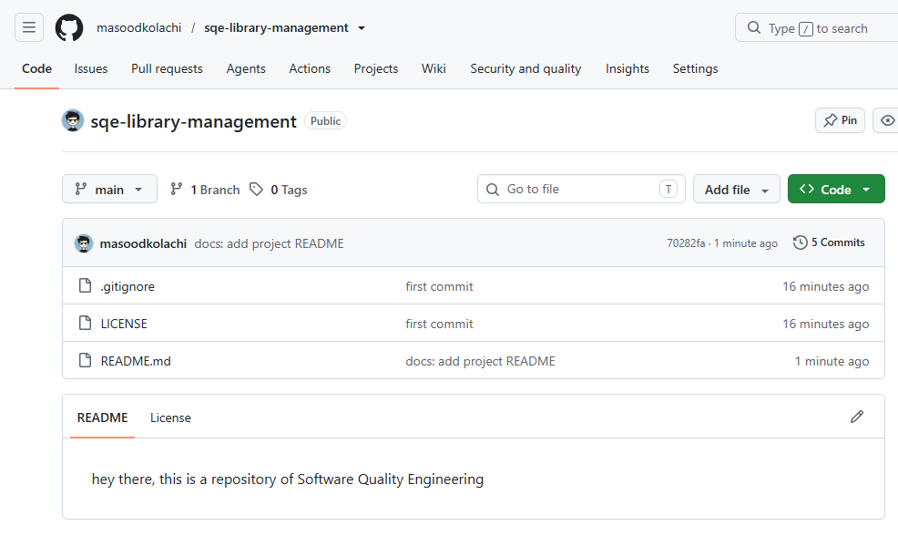
Screenshot of the repository

URL of the repository: https://github.com/masoodkolachi/sqe-library-management

